
Setting up for Success
An important step of the Sustainable Schools Program is capturing the sustainability work you are doing. We do this in the Sustainable Schools Program Online system (SSP Online). Think of SSP Online as a repository for all the evidence of your school’s sustainability journey – a map to guide you. This document outlines the steps you should take to help you get organised.

Sustainable Schools Program snapshot

General
- The Sustainable Schools Program provides schools with a framework and practical support to make cost savings, integrate the pillars of sustainability into the curriculum, make an impact in the school community, and share learnings beyond the school gate.
- Figures 1 and 2 outline the framework which contains five modules (Core, Biodiversity, Energy, Waste, Water) that look at improving sustainability through three key areas:
- Workplace/operational
- Learning and teaching
- Whole school community engagement
- To meet the sustainability requirements of the modules, schools must complete a set of actions. There are compulsory and recommended actions, which vary depending on the module.
- Once the sustainability requirements are met, the Sustainable Schools Program team will certify your module, and your school will receive a certificate.
- Once your school has completed various actions across modules, you can opt in for sustainability star certification.

Modules
- The Core module is the foundation of your school sustainability journey. It is focused on school operations. We recommend that this module is completed first as it sets up your whole school community for success.
- The Biodiversity, Energy, Waste, and Water Modules include actions that will assist your school to reduce resource use, make cost savings, integrate sustainability into the curriculum, and share learnings beyond the school gate.
- You might choose to focus on one module at a time (this might sit well with a project you are undertaking) or dip into some or all of the modules at the same time.

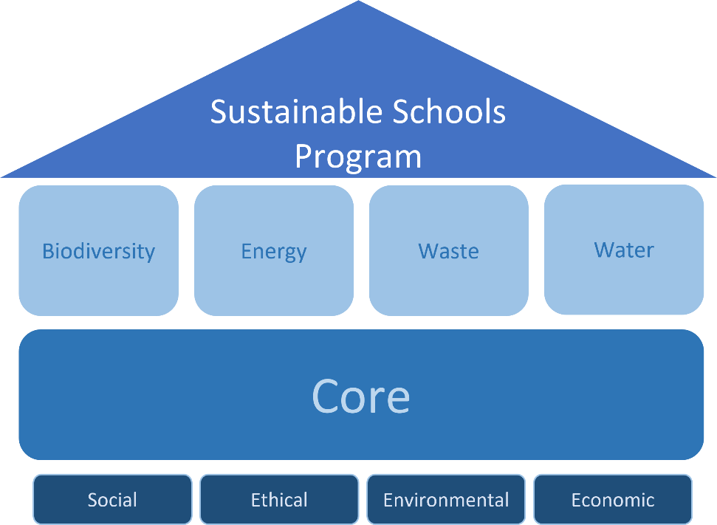

Figure 1: The Sustainable Schools Program sustainability framework. The Core module allows you to incorporate sustainability best practice into your workplace, curriculum, and community to build a strong foundation to help you manage resources effectively and improve biodiversity.
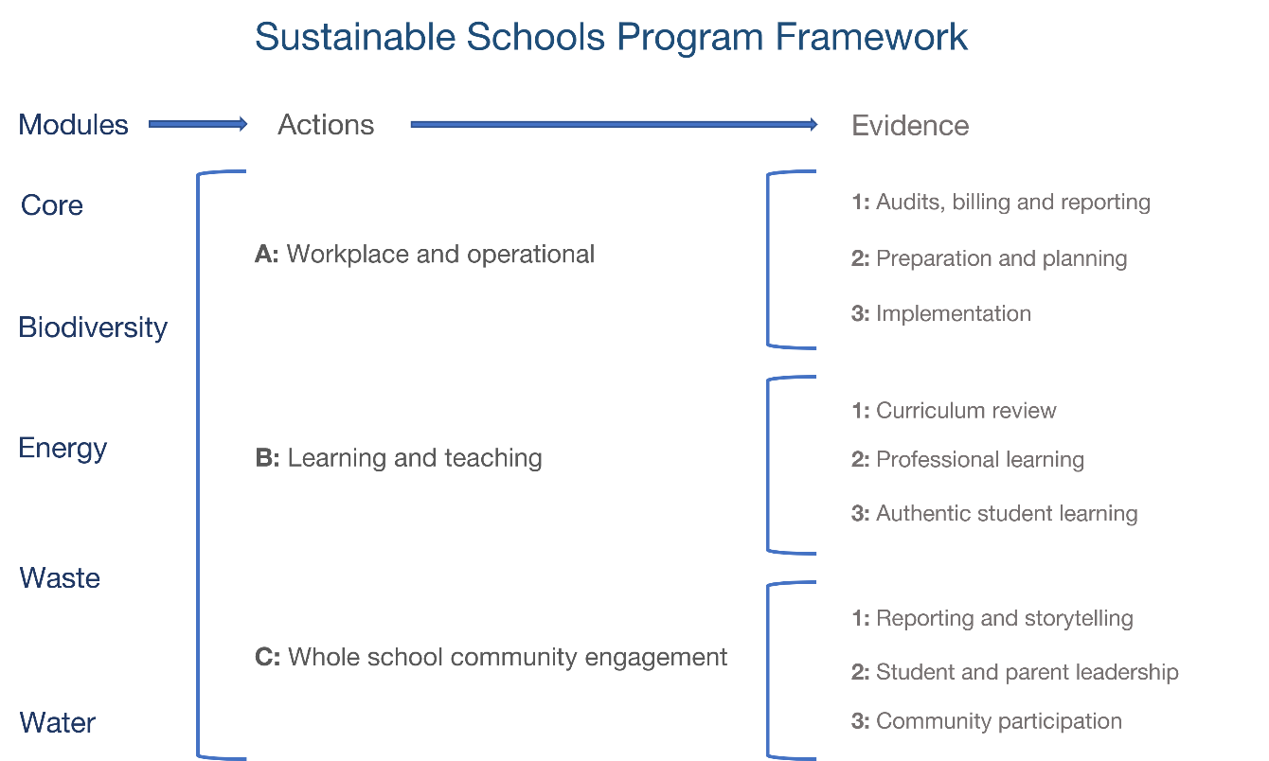

Figure 2: The Sustainable Schools Program framework is based on five modules; each have a variety of actions that should be completed with supporting evidence. SSP Online will allow you to track and capture your progress and future proof your school’s sustainability plans.

Organise your supporting documentation
Many of the module actions require evidence to be uploaded. You can upload as many pieces of evidence as you want to in an action. Some actions have specific requirements. More information about those can be found in the modules in SSP Online.
The system will allow you to upload a range of file formats:
- Photos (jpeg format – under 2MB)
- Website links
- Word, Excel, PowerPoint (under 5MB)
- PDFs are recommended (under 5MB).
Do not upload password-protected links. These can become obsolete, and we may not be able to access the material.
A great way to organise evidence is to create a dedicated SSP Online folder on your computer for documents associated with each module. If this folder is in a shared drive, everyone can add documents to the folder. Refer to Figure 3 as an example.
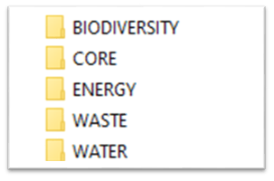

Figure 3: Image of folders using Sustainable Schools Program Online module names: Biodiversity, Core, Energy, Waste, and Water.
Supporting documentation can take different forms. Some examples are:

- Screenshot of social media posts
- Newsletter grabs
- School policies
- Learning outlines and lesson plans
- Photos with captions
- Audits/surveys/results
- Copies of emails
- Deidentified copies of student work
- Grant applications
- Action plans
- School learning stories
- Presentation notes, cue cards, or slide decks.

Clear supporting documentation enables the person certifying your module to contextualise your school actions and reduces the need to provide further details.

Use naming conventions
Make sure the supporting documentation is accurately named. This makes it easy to find your files and when it comes to certifying the module. Include a date and year in the document name.
Refer to Figure 4 as an example. The documents outside of the red oval are named in a way that someone who is unfamiliar with the school’s work can understand what the evidence refers to. However, the generic names in the red oval are not clear.
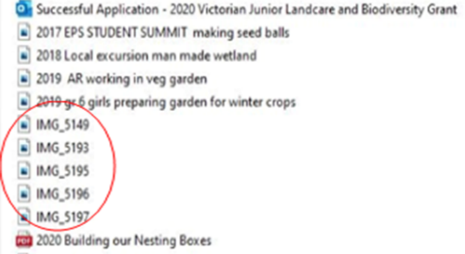

Figure 4: Using a naming convention for your documents helps you keep track of your documentation and simplify certification.

Evidence for multiple modules or actions
There are various resources available to support you in completing the module actions. Providing effective evidence to demonstrate the completion actions allows the Sustainable Schools Program assessor to certify your modules. This evidence needs to be uploaded to SSP Online with the relevant action.
The trick here is to work smarter! Use the Module Checklists (available here or on SSP Online) to check if your piece of evidence can support actions across different modules or actions. When you upload your evidence, you can tag various modules and actions. For example:
You have written a newsletter article that shows how the school is working hard to collect all your food waste. This is used to feed chooks, the worm farm, and is also composted. The newsletter article will support actions in the Waste and Biodiversity modules.
If the work you are doing in this area has been linked to student learning – such as an understanding of soils, worms, and/or waste reduction, you can link it to the Learning and Teaching Actions (B Actions) in both the Biodiversity and Waste modules.
Perhaps the newsletter article included some tips and tricks to help people start their own compost at home. Then you can also link this piece of evidence to Community and Communication Links actions (C Actions).
Remember - the trick is to work smarter!

Writing a great comment
Many SSP Online actions require you to enter a comment. When writing these, consider the five Ws: What, When, Who, Where, and Why. For example:
We participated in local biodiversity activities on 7 July 2022. The grade 3 to 6 students attended a tree planting day coordinated by the ACT Landcare group to increase biodiversity of the Best River nature reserve.
While comments within the modules don’t need to be long, they need to provide enough information to demonstrate the completion of the action within a module.
Upon module certification, users need to write a final comment. This should still consider the 5 Ws, however, it should also be reflective of the whole module, incorporate the three key elements of the module, and provide the assessor with information that demonstrates whole school participation in sustainability.

Star Progression
The Sustainable Schools Program sustainability star certification is all about your school demonstrating continuous improvement against the baseline you set in the areas of biodiversity, energy, waste, and water. Figure 5 provides an overview of this process. It aims to help your school:
- integrate sustainability into your planning and strategic processes,
- develop ways to improve resource management
- embed sustainability practices into the school operations, teaching, learning, and community engagement.
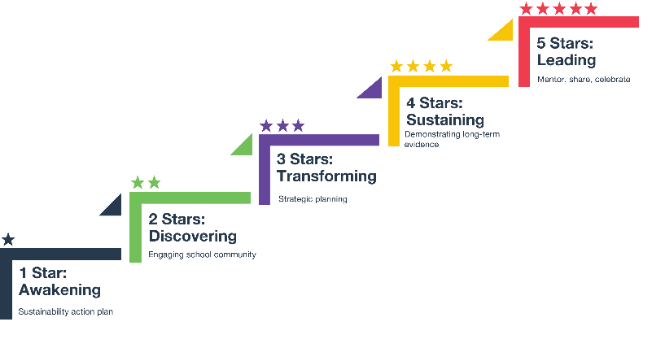


Figure 5: An outline of the Sustainable Schools Program sustainability star certification. More information is found on SSP Online.

